Alpha - Version
SRS DOCUMENT
(Software Requirements Specification)
Project Manager: Bheka Mbhele
Project: Sand Lab Testing System
Plant: High Chrome Ball Plant
Version: 1.0.0.0
Prepared by: Tsundzukani Martin Nkuna
From Date: 2025/ 11/ 03 To Date: 2025/ 11/ 03

Project Objectives: The objective of the project is to allow Users to Register, Login and Manage Sand Lab Test Records
Table of Contents
INTRODUCTION 4
PROJECT OVERVIEW 4
1.1. Project Purpose 4
1.2. Project Scope 5
1.2.1 User 5
1.2.2 System 6
1.2.3 Database 6
1.3 Business Rules & Business Requirements 6
1.3.1 User Management 6
1.3.2 System Management 7
1.3.3 Database Management 7
1.4 Project Development Environment & Project Constraints 8
1.5 Business / System Feature 9
FUNCTIONAL REQUIREMENTS 10
2.1 Database Design Diagram 10
2.1.1 ERD – Entity Relationship Diagram 10
2.2 System Design Diagram 11
2.2.1 Activity Flow 11
11
2.2 User Design Diagram 12
2.2.1 Use Cases Figure 12
2.3 Use Cases Specification 13
2.3.1 UC.01 13
2.3.2 UC.02 14
2.3.3 UC.001 16
2.3.4 UC.03 18
18
2.3.5 UC.04 19
NON – FUNCTIONAL REQUIREMENTS 21
3.1 Technical Requirements 21
3.1.1 Platform 21
3.1.2 Technology Stack 21
3.1.3 Architectural Design Patterns 21
3.2 Data Requirements 21
3.2.1 Data Storage 21
3.2.2 Data Input 21
3.2.3 Usability Requirements 21
3.3 Support / Security Requirements 22
3.3.1 Availability Requirements 22
3.3.2 Performance Requirements 22
3.3.3 Safety Requirements 22
3.3.4 Security Requirements 22
CONCLUSION 22

INTRODUCTION
This Software Requirements Specifications Template defines the final elements of the Sand Lab Testing System – Alpha Version, intended for Development at the High Chrome Ball Plant. Under the guidance of Project Manager Bheka Mbhele and technical ownership by Tsundzukani Martin Nkuna.

PROJECT OVERVIEW

1.1. Project Purpose
The system aims to improve accuracy, efficiency, and accessibility of sand sample data by providing:
- User Management: Secure registration, login, and recovery of credentials, ensuring that only authorized personnel can access and manage sand samples.
- System Accessibility: Access via web browsers, tablets, and mobile devices, with user input validation, protected data, and scheduled maintenance notifications.
- Database Management: Automated storage, retrieval, and updating of batch records, lab sand samples, and Disa log sheet information, while preventing duplicate entries and ensuring data integrity.

1.2. Project Scope
The Sand Lab Testing System for the High-Chrome Ball Plant is being developed to automate the collection, storage, and presentation of Sampled Lab Sand for Line 1, Line 2, and Line 3.

1.2.1 User
Each user who wants to use the system on a given day:
- Must Register only if they are first time System User without Registration details
  - Allow a user to register only using their work email address with domain @ magotteauxgmsa.com
  - On registration success send notification email address containing login details
  - On registration failure display alert box / message box notifying user registration failed
  - A User who registers on the system with null values multiple times will be blocked, and registration access will be given after a specific time

- Allow them to recover their login details if they forget them.
  - Recovery can either be with registered email address, Cell Number or Clock Number
  - Multiple login details recovery with wrong registered details will results in a user being blocked in accessing the system for a specific time
- Login to the System using registration email address and password
  - Multiples logins retry with failure will result in a user being blocked for a specific time
  - Only Logged in user will have access to sand batch numbers
  - Have access to samples or be able to sample new sand batch number
  - Alter / update samples
  - Export / download samples

1.2.2 System
System Accessibility Points — How the system will be accessed
- For web browser a browser website will be given to access the system
- For tablet or mobile access, an APK link will be provided to download the system.
- The system will validate user input to ensure that null values are not accepted.
- The system will be accessible during standard plant operating hours (24/7).
- A scheduled downtime will be communicated 24 hours in advance.
- This is private data and sand results are part of MGMSA’s intellectual property that needs to be protected from unauthorised access.

1.2.3 Database
The database shall perform the following functions:
- Automatically connects to Microsoft SQL Server Management Studio using a stored connection string to access the system database.
- The database stores and retrieve all batch records processed through the Sand plant Scada, for each casting line.
- The database stores and retrieve specific Disa log sheet records such as Grade, Press Pour Temperature and Mould Thickness
- The database stores, alter and retrieve sand samples from the lab for each production line.
- The database stores, alter and retrieve user registration information and duplicates are not accepted.

1.3 Business Rules & Business Requirements

1.3.1 User Management

1.3.1.1 Registration
Business Rule | Business Requirements
- Email Address with domain @magotteauxgmsa.com | - Authorisation – on registration success to send login details
- Valid Contact Number | - Authorisation

1.3.1.2 Login
Business Rule | Business Requirements
- Email Address | - Authentication
- Password | - Authentication

1.3.1.3 Recover Login Details
Business Rule | Business Requirements
- Registered Email Address, Contact Number or Clock Number | - Authentication

1.3.2 System Management

1.3.2.1 Registration
Business Rule | Business Requirements
- Contact Information | - Validation – Validate against null values  - Validation – validate email with domain @magotteauxgmsa.com  - Validation -validate 10 digits cell number

1.3.2.2 Login
Business Rule | Business Requirements
- Login Details | - Validation – Validate against null values

1.3.2.3 Recover Login Details
Business Rule | Business Requirements
- Registered Email Address, Contact Number or Clock Number | - Validation – Validate against null values

1.3.2.4 Shift Schedule
Business Rule | Business Requirements
- Shift Selector | - Validation – Validate against null values  - Valid shift Schedule  - Valid Foreman Names

1.3.3 Database Management

1.3.3.1 Registration
Business Rule | Business Requirements
- Contact Information | - Persist -store registered information  - Verification – verify if user already exist to avoid duplicates  - Validate
- Email Address | - Verification – verify email with domain @magotteauxgmsa.com  - Validate
- Password | - Hashed Password

1.3.3.2 Login
Business Rule | Business Requirements
- Login Details | - Verification – verify if user already registered / login details exist

1.3.3.3 Recover Login Details
Business Rule | Business Requirements
- Registered Email Address, Contact Number or Clock Number | - Verification – verify if user contact detail is registered

1.4 Project Development Environment & Project Constraints
- Development Start: 27th October 2025
- Testing Phase: Frequently after Updates
- Go-Live: Frequently after Updates approval
- Team:
  - MIS Technician Trainee
- Technology:
  - IIS (Internet Information Services)
  - Microsoft SQL Server Management Studio
  - Visual Studio Code
  - Android Studio

1.5 Business / System Feature
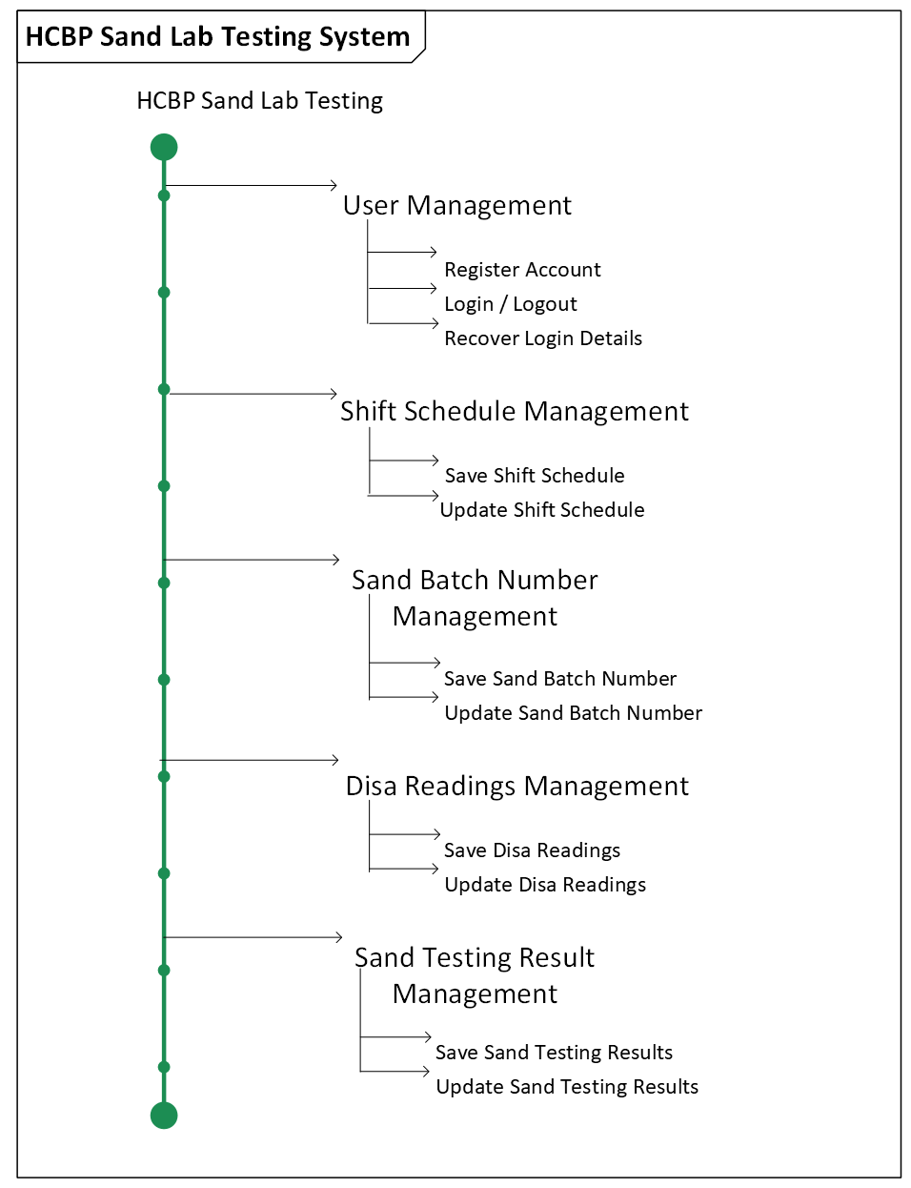

FUNCTIONAL REQUIREMENTS

2.1 Database Design Diagram

2.1.1 ERD – Entity Relationship Diagram
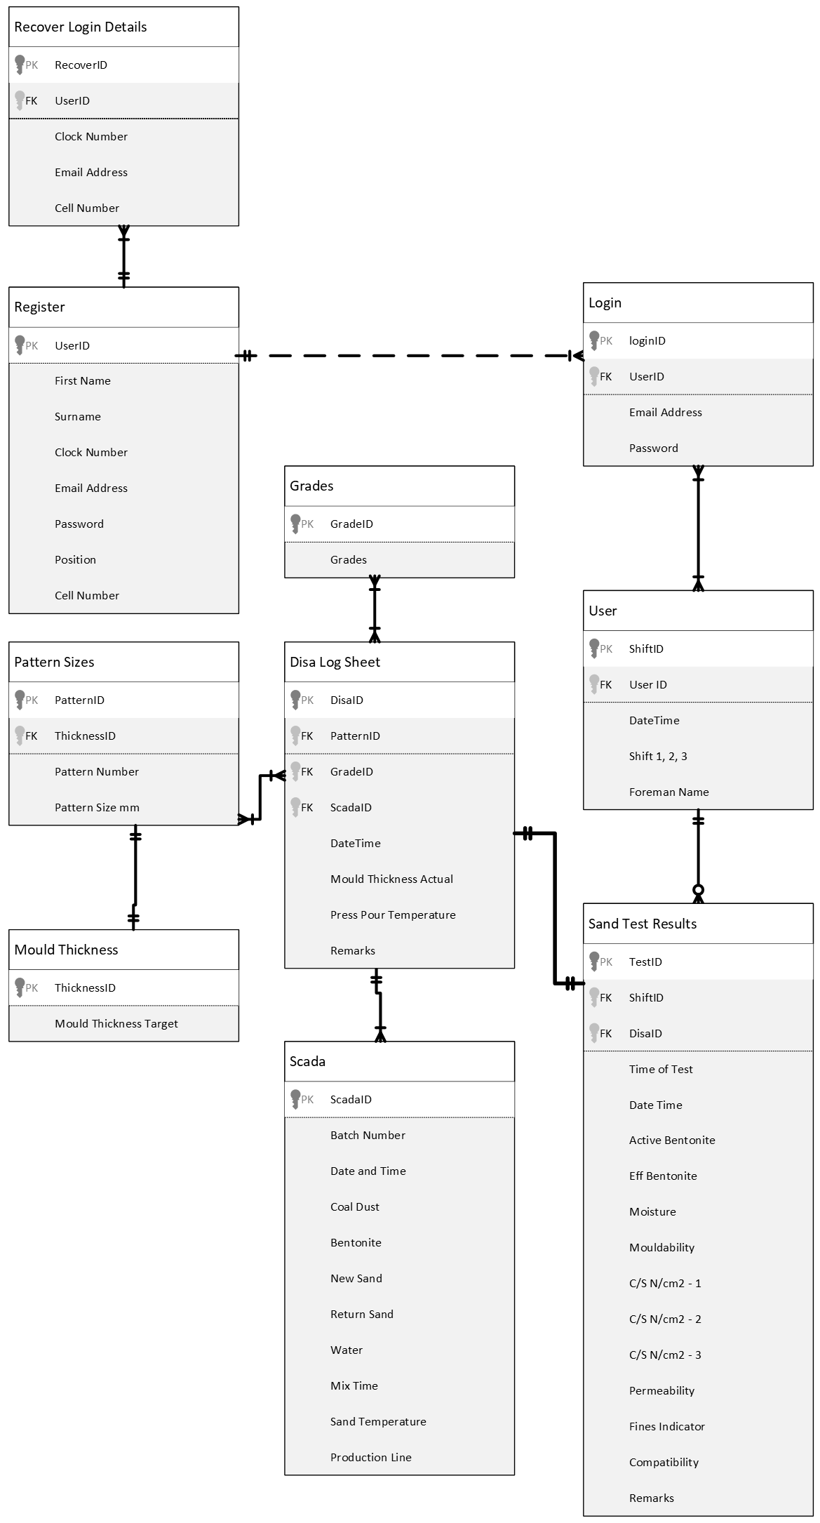

2.2 System Design Diagram

2.2.1 Activity Flow

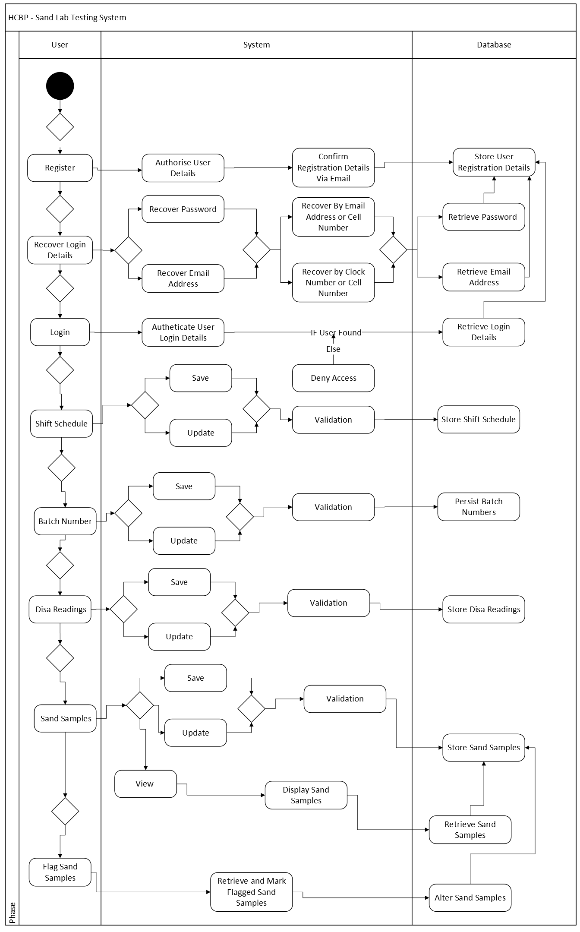

2.2 User Design Diagram

2.2.1 Use Cases Figure
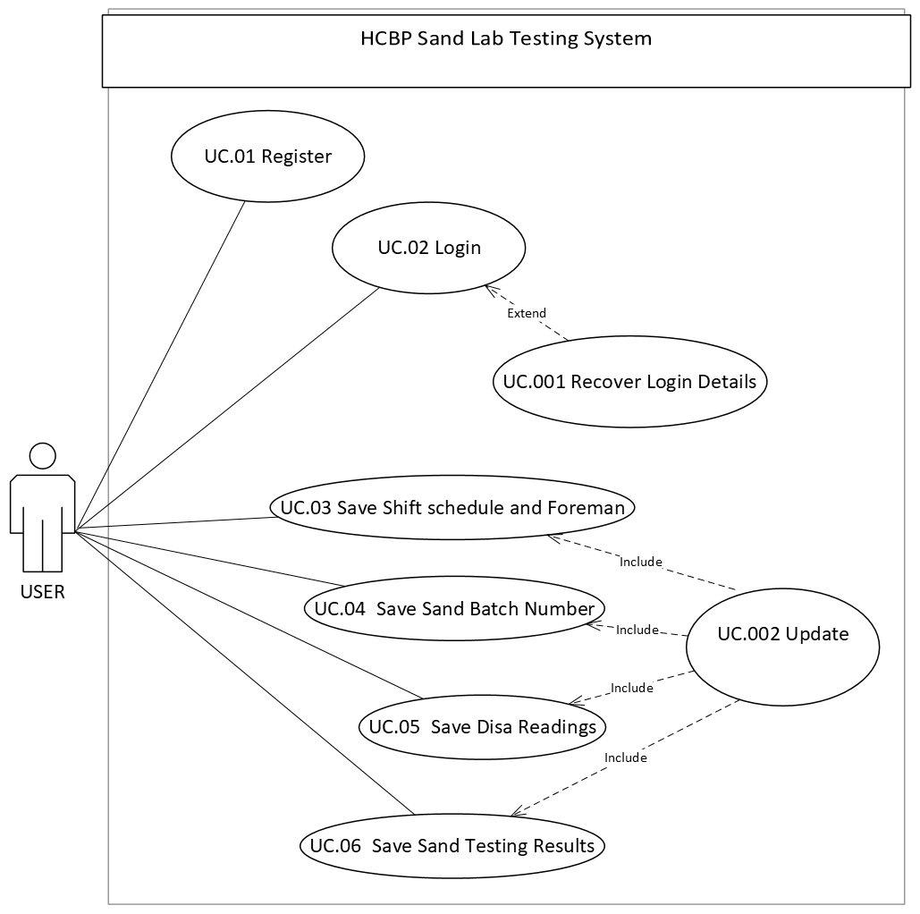

2.3 Use Cases Specification

2.3.1 UC.01
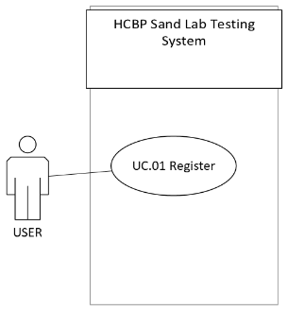
Use Case: short active verb
Use Case ID | UC.01
Use Case Name | Register
Actor(s) | End-User
Description | This use case allows a new user to create an account in the system.
Precondition | - The user is not already registered in the system.  - The registration page or form is available and accessible.  - The system is online and functioning properly.
Post-condition | - A new user account is created and stored in the database  - The user receives confirmation of successful registration.
Alternate Flow | A1. Email Already Registered  - Steps 1–4 as in the main flow.  - The system checks the email and finds that it already exists.  - The system displays an error message: “Email already registered. Please log in or use another email.”  A2. Invalid Input Data  - Steps 1–4 as in the main flow.  - The system finds invalid or missing fields (e.g., password too short, invalid email format).  - The system highlights errors and prompts the user to correct them.  A3. System Unavailable  - The user attempts to open the registration page.  - The system is down, or the database is unavailable.
Exceptions | - During step 4 (account creation), the system cannot connect to the database.  - The system encounters an unrecoverable error (e.g., server crash, timeout).
Main flow of events | Step | User action | System response
 | 1. | The user opens the registration page. | The system displays the registration form.
 | 2. | The user enters required details (name, email, password, etc.).
 | 3. | The user submits the registration form. | The system validates the input data.
 | 4. |  | The system creates a new user account.
 | 5. |  | The system displays a confirmation message.

2.3.2 UC.02
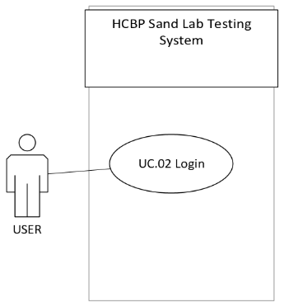
Use Case: short active verb
Use Case ID | UC.02
Use Case Name | Login
Actor(s) | End-User
Description | This use case allows a registered user to log into the system using valid credentials (e.g., email/username and password). Once authenticated, the user gains access to authorized features of the system.
Precondition | - The user must already be registered in the system.  - The login page or interface is available and accessible.  - The system and authentication service are operational.
Post-condition | - (Success): The user is authenticated and gains access to the system’s main page or dashboard.  - (Failure): The system remains in the login state; no session is created.
Alternate Flow | A1. Invalid Username or Password  - Steps 1–6 as in the main flow.  - The system detects incorrect credentials.  - The system displays an error message: “Invalid username or password. Please try again.”  A2. Account Locked or Suspended  - Steps 1–6 as in the main flow.  - The system detects that the user’s account is locked (e.g., due to multiple failed attempts or admin action).  - The system displays a message: “Your account has been locked. Please contact support.”  A3. Forgot Password Option  - Steps 1–2 as in the main flow.  - The user selects “Forgot Password.”  - The system directs the user to the password recovery process.
Exceptions | - During credential verification, the system cannot connect to the database or authentication service.  - The system encounters an unexpected crash or timeout.
Main flow of events | Step | User action | System response
 | 1. | The user opens the login page. | The system displays fields for username/email and password.
 | 2. | The user enters valid credentials.
 | 3. | The user clicks the Login button. | The system validates the input format (e.g., no empty fields).
 | 4. |  | The system verifies the credentials against stored data.
 | 5. |  | The credentials are valid — the system authenticates the user.
 | 6. |  | The system creates a user session.
 | 7. |  | The system redirects the user to the dashboard (or home page).

2.3.3 UC.001
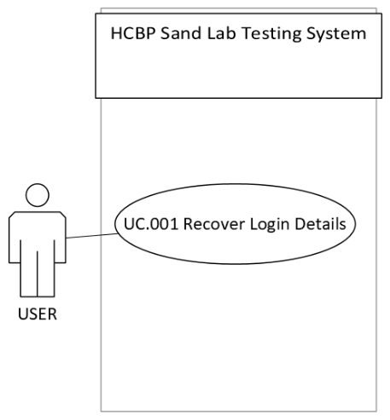
Use Case: short active verb
Use Case ID | UC.001
Use Case Name | Recover Login Details
Actor(s) | End-User
Description | This use case allows a registered user who has forgotten their login details (e.g., password) to recover access to their account by verifying their identity through email or another secure method.
Precondition | - The user must already be registered in the system.  - The login page or recovery page is available and accessible.  - The system’s email or notification service is operational.
Post-condition | - (Success): The user’s identity is verified, and a password reset link or recovery option is provided.  - (Failure): No password change occurs; the user remains unauthenticated.
Alternate Flow | A1. Email Not Registered  - Steps 1–4 as in the main flow.  - The system cannot find the entered email in its records.  - The system displays: “No account found with that email address.”  A2. Invalid or Expired Recovery Link/Code  - Steps 1–7 as in the main flow.  - The user clicks an expired or invalid recovery link.  - The system displays: “This link has expired or is invalid. Please request a new one.”  A3. Weak Password on Reset  - Steps 1–7 as in the main flow.  - The user enters a new password that doesn’t meet security criteria.  - The system displays: “Password must be at least 8 characters and contain letters and numbers.”
Exceptions
  - The system displays: “Recovery service temporarily unavailable. Please try again later.”
  - The system encounters an internal error or timeout.
Main flow of events | Step | User action | System response
 | 1. | The user selects the “Forgot Password” or “Recover Login Details” option from the login page. | The system displays the password recovery form.
 | 2. | The user enters their registered email address (or username). | The system validates that the input format is correct.
 | 3. |  | The system checks if the email/username exists in the database.
 | 4. |  | The system generates a secure, time-limited recovery token or link.
 | 5. | The user opens their email and clicks the recovery link (or enters the verification code). | The system displays the password reset form.
 | 6. | The user enters a new password and confirms it. | The system updates the password and confirms success.
 | 7. | The user can now log in with the new password.

2.3.4 UC.03

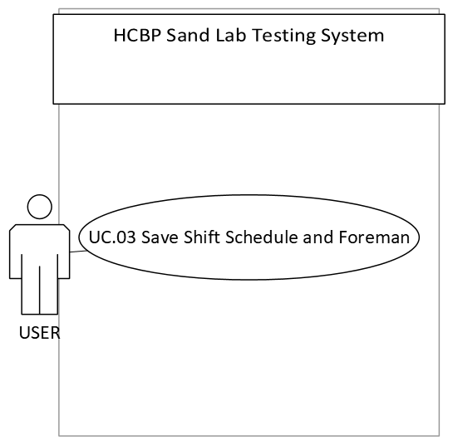

Use Case: short active verb
Use Case ID | UC.03
Use Case Name | Save Shift Schedule
Actor(s) | End-User
Description | This use case allows a foreman or authorized user to create, edit, and save a work shift schedule.
Precondition | - The User is logged in with valid credentials.  - The employee list is available and up to date.  - The scheduling system is online and accessible.
Post-condition | - (Success): The new or updated shift schedule is saved and available.  - (Failure): No changes are saved; the system remains unchanged.
Alternate Flow | A1. Unsaved Changes Warning  - The User attempts to leave the scheduling page without saving.  - The system displays a warning: “You have unsaved changes. Save before exiting?”  - The User chooses whether to save or discard changes.
Exceptions | - The system logs the error and displays: “Unable to save schedule. Please try again later.”  - The system experiences a crash or timeout.
Main flow of events | Step | User action | System response
 | 1. | The User navigates to the scheduling page. | The system displays the current or blank shift schedule.
 | 2. | The User selects a date range (e.g., week or month).
 | 3. | The User assigns them to their current shift. | The system validates shift entries (no overlapping shifts, required coverage met).
 | 4. | The User clicks Save Schedule. | The system saves the schedule to the database.
 | 5. |  | The system displays a confirmation message: “Shift schedule saved successfully.”

2.3.5 UC.04
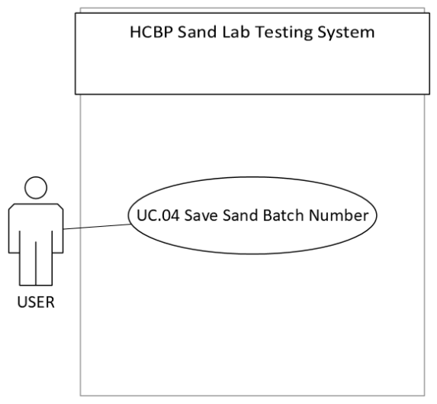
Use Case: short active verb
Use Case ID | UC.04
Use Case Name | Save Sand Batch Number
Actor(s) | End-User
Description | This use case allows an authorized user (e.g., a foreman or production operator) to enter and save a sand batch number into the system
Precondition | - The user (foreman/operator) is logged in and authorized to manage batch information.  - The system is online and connected to the production database.  - The sand batch has been received and identified physically (e.g., labelled or documented).
Post-condition | - (Success): The sand batch number and its associated details are successfully saved in the system and linked to production records.  - (Failure): The sand batch number is not saved, and the system state remains unchanged.
Alternate Flow | A1. Duplicate Batch Number Detected  - Steps 1–6 as in the main flow.  - The system detects that the same sand batch number already exists.  - The system displays: “Batch number already exists. Please verify or enter a new one.”  A2. Missing Required Data  - Steps 1–4 as in the main flow.  - One or more mandatory fields (e.g., batch number, supplier) are blank.  - The system highlights missing fields and displays: “Please complete all required fields.”
Exceptions | - The system displays: “Unable to save batch number. Please try again later.”  - The system encounters a timeout or crash before confirming save.
Main flow of events | Step | User action | System response
 | 1. | The foreman navigates to the Materials Entry or Batch Management page. | The system displays the sand batch entry form.
 | 2. |  | The system validates the input fields (e.g., batch number format, required fields).
 | 3. | The foreman clicks Save. | The system checks for duplicates in existing batch records.
 | 4. |  | The system saves the batch number and details into the database.
 | 5. |  | The system confirms with a message: “Sand batch number saved successfully.”

NON – FUNCTIONAL REQUIREMENTS

3.1 Technical Requirements

3.1.1 Platform
- The system will run on:
  - Microsoft Edge, Google Chrome or Web Browser
  - Mobile Device/ Tablet
  - SQL Server for database backend
  - Accessible via IIS (Internet Information Services)
  - APK Link for Mobile/Tablet Version Download

3.1.2 Technology Stack
  - Frontend: Android Studio - Flutter
  - Backend: Visual Studio Code – Node.js and Express
  - Database: Microsoft SQL Server

3.1.3 Architectural Design Patterns
  - MVC – Back End
  - MVVM – Front End
  - Database – Erd
      - Tables
      - Stored Procedure

3.2 Data Requirements

3.2.1 Data Storage
  - MSQL Server Database
  - Data Schema
  - Stored Procedure

3.2.2 Data Input
  - Validated User Inputs
  - Domain @Magotteauxgmsa.com
  - Authentication
  - Authorisation

3.2.3 Usability Requirements
  - Android / IOS Cell phone
  - Tablet / iPad
  - Desktop / Laptop
  - The interface should be simple, intuitive, and easy to navigate.
  - Users should be able to easily view and understand the data displayed.

3.3 Support / Security Requirements

3.3.1 Availability Requirements
- The system must be available at least 99.75% of the time during business hours (24/7 preferred for plants running continuously).
- Database and application services should be backed up with a disaster recovery plan.

3.3.2 Performance Requirements
- The system must load filtered data queries within 15 seconds.
- The system must support concurrent access by at least 50 users without performance degradation.
- Export functions (XLSX/PDF) must complete within 5 seconds under normal load.

3.3.3 Safety Requirements
- The system prevents data corruption or loss during unexpected shutdowns through regular automated backups and transaction logging.
- Input validations are implemented to prevent accidental or malicious entry of harmful data.

3.3.4 Security Requirements
- Data Transmission: All data transmitted between client and server must be secured.
- Data Protection: Stored data must be protected against unauthorized access, tampering, or deletion.

CONCLUSION

